
UNIVERSITY OF THE EAST – CALOOCAN
COLLEGE OF ENGINEERING
Computer Engineering Department

MACHINE PROBLEM #2

“Array”

NCP 1203 – Data Structures and Algorithms
2CP

Submitted To:
DR. JOAN P. LAZARO
CpE Professor

Submitted By:
DANIOT, GABRIEL F.

DATE OF SUBMISSION
DECEMBER 12, 2019

HANDS-ON ACTIVITY (MACHINE PROBLEM NO. 2)
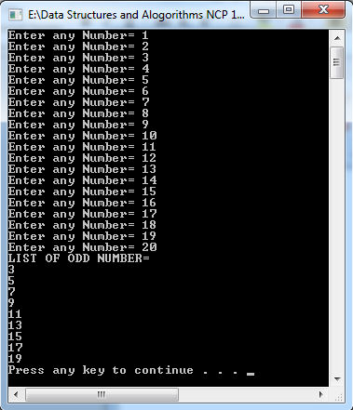
1. Create a C++ program that determines the ODD numbers among 20 input values and output the list of these ODD numbers
#include<iostream>
using namespace std;
int main()
{
int a[20];
int ctr;
for(ctr=0;ctr<=19;ctr++)
{
cout<<"Enter any Number= ";
cin>>a[ctr];
}
cout<<"LIST OF ODD NUMBER= "<<endl;
for(ctr=1;ctr<=19;ctr++)
if(a[ctr] % 2 != 0 )
cout<<a[ctr]<<endl;
system("pause");
}

2. Build a C++ program that will input 15 values and arranged it from highest to lowest.
#include<iostream>
using namespace std;
int main()
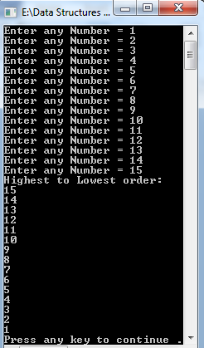
{
int a[15];
int ctr1,ctr2,temp;
{
for(ctr1=0;ctr1<=14;ctr1++)
{
cout<<"Enter any Number = ";
cin>>a[ctr1];
}
for(ctr1=0;ctr1<=14;ctr1++)
for(ctr2=ctr1+1;ctr2<=14;ctr2++)
{
if(a[ctr2]>a[ctr1])
{
temp=a[ctr1];
a[ctr1]=a[ctr2];
a[ctr2]=temp;
}
}
cout<<"Highest to Lowest order: "<<endl;
for(ctr1=0;ctr1<=14;ctr1++)
cout<<a[ctr1]<<endl;
system("pause");
}
}
3. Create a C++ program that determines the NEGATIVE numbers among 10 input integers and output the list of these NEGATIVE numbers
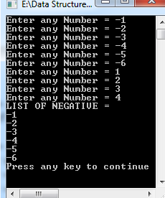
#include<iostream>
using namespace std;
int main()
{
int a[10];
int ctr;
for(ctr=0;ctr<=9;ctr++)
{
cout<<"Enter any Number = ";
cin>>a[ctr];
}
cout<<"LIST OF NEGATIVE = "<<endl;
for(ctr=0;ctr<=9;ctr++)
if(a[ctr] < 0 )
cout<<a[ctr]<<endl;
system("pause");
}

4. Create a C++ program using array that determines the number of ODD and EVEN numbers among 10 input values.
#include<iostream>
using namespace std;
int main()
{
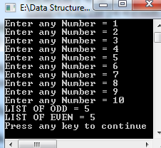
int a[10];
int ctr,odd = 0, even = 0;
for(ctr=1;ctr<=10;ctr++)
{
cout<<"Enter any Number = ";
cin>>a[ctr];
}
for(ctr=1;ctr<=10;ctr++)
if(a[ctr] % 2 == 1)
odd = odd + 1;
for(ctr=1;ctr<=10;ctr++)
if(a[ctr] % 2 == 0)
even = even + 1;
cout<<"LIST OF ODD = "<<odd<<endl;
cout<<"LIST OF EVEN = "<<even<<endl;
system("pause");
}

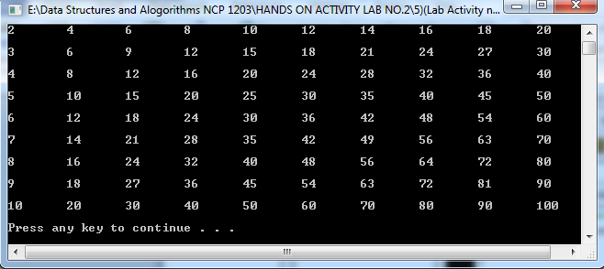
5. Create a 10x10 multiplication table.
#include<iostream>
using namespace std;
int main()
{
int ctr1[10][10];
for (int ctr2 = 0; ctr2 < 10; ctr2++)
{
for(int ctr = 0; ctr < 10; ctr++)
{
ctr1[ctr2][ctr] = (ctr2 + 1) * (ctr + 1);
}
}
for(int ctr2 = 1; ctr2 < 10; ctr2++)
{
for(int ctr = 0; ctr < 10; ctr++)
{
cout<< ctr1[ctr2][ctr] <<"\t";
}
cout<<endl;
}
system("pause");
}
6. Create a C++ program using a 4x4 array, search a number, then determine and output the list of times it occurs on the list of 16 numbers entered.
#include<iostream>
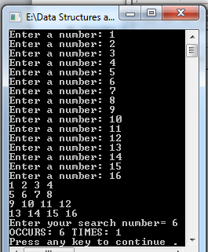
using namespace std;
int main() {
int a[4][4];
int x,y,search=0,ctr=0;
//INPUT FOR ARRAY
for(int x = 0; x < 4; x++) {
for (int y = 0; y < 4; y++) {
cout << "Enter a number: ";
cin >> a[x][y]; }}
//OUTPUT
for(int x = 0; x < 4; x++) {
for (int y = 0; y < 4; y++){
cout << a[x][y] << " ";}
cout << endl;}
cout<<"Enter your search number= ";
cin>>search;
for (x=0;x<=4;x++)
{
for(y=0;y<=4;y++)
{if (a[x][y]==search)
ctr++;}}
cout<<"OCCURS: "<<search;
cout<<" TIMES: "<<ctr<<endl;
system("pause");}
7. Create a C++ program that allows the user to enter 5x5 array of integer type and a search number. Your program will output the index of your search number.

#include<iostream>
using namespace std;
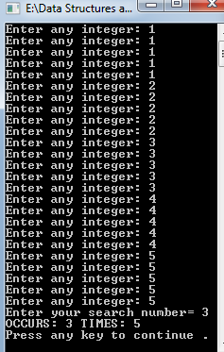
int main()
{
int A[5][5];
int x,y,search=0,ctr=0;
for (x=0;x<=4;x++)
{
for(y=0;y<=4;y++)
{
cout<<"Enter any integer: ";
cin>>A[x][y];
}
}
cout<<"Enter your search number= ";
cin>>search;
for (x=0;x<=4;x++)
{
for(y=0;y<=4;y++)
{if (A[x][y]==search)
ctr++;}}
cout<<"OCCURS: "<<search;
cout<<" TIMES: "<<ctr<<endl;
system("pause");
}

Reflection:
For me studying and learning array in C++ is very challenging because it’s a lot of work but I still understand it in the lesson. You will learn to work with arrays. You will learn to declare, initialize and access array elements of an array with the help of examples. At first, the element must start at 0 and the next value can depend on what the user wanted it to loop. Also, in addition, there are two types of array, the one dimensional or single dimensional array which can present a single list of values.

8. INTEGRATION OF ARRAY USING MENU
